Here are some screenshots from the python Lab 3

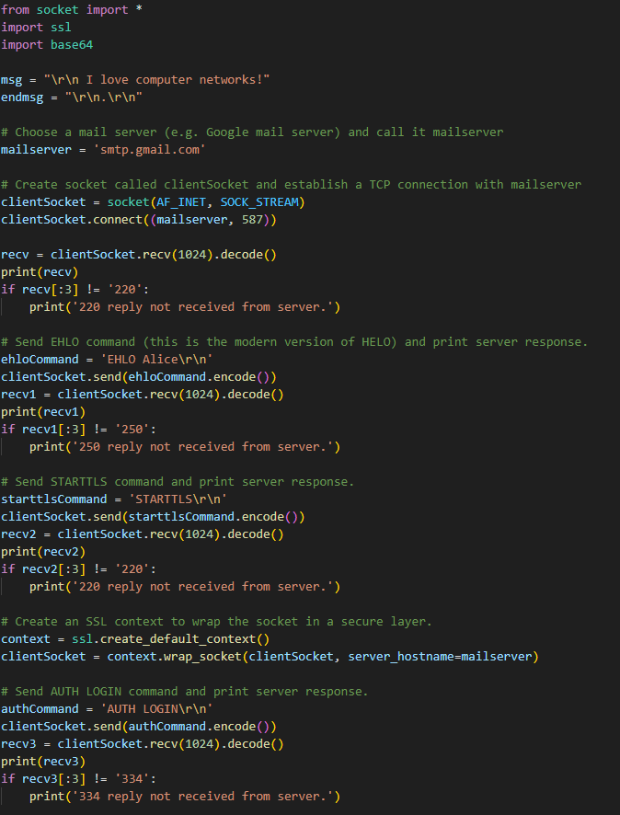

This is the python code

This is the output message.

This is the mail received.

**Experience Summary:**

Working on this SMTP email-sending script was both an enriching and practical experience. It provided an opportunity to delve into the foundational protocols of email communication and understand the SMTP workflow better. From establishing a TCP connection with the mail server to using secure communication via STARTTLS, every step required careful implementation to ensure proper interaction with the mail server. One of the highlights was learning how commands like EHLO, MAIL FROM, and RCPT TO work in sequence to facilitate the process of sending an email programmatically. Encoding the credentials with Base64 and wrapping the socket with an SSL layer were key elements that showcased the importance of security in modern networking practices. Overall, this exercise was a rewarding hands-on experience that reinforced both theoretical and practical networking concepts.

**Challenges Faced:**

One of the main challenges was handling server responses correctly and ensuring compliance with SMTP protocol requirements. For example, recognizing server replies (e.g., 250, 334) and implementing error handling for non-standard responses required careful attention. Setting up authentication posed another hurdle, as it involved managing app-specific passwords securely and encoding sensitive data. Additionally, troubleshooting issues such as mismatched STARTTLS or authentication failures often required multiple iterations and research to resolve. Another complexity was ensuring that the sequence of SMTP commands was correctly implemented, as any deviation could result in server rejection or incomplete communication. Despite these challenges, resolving them enhanced my understanding of secure email protocols and debugging techniques in network programming.